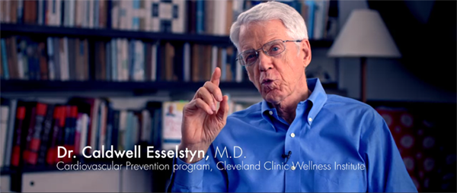
Dr. Esselstyn: "All this expensive imaging, procedures, bypasses, medications, none of which have one single solitary thing to do with causation of the illness...so we DIE of a completely benign, food borne illness, THAT NEVER HAD ITS CAUSE TREATED. The problem is that the ANIMAL based diet contribution to heart disease is HUGE."

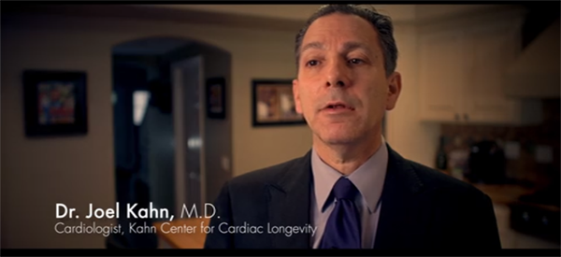
Dr. Joel Kahn, Cardioligist: "The diabetes, the arthritis, the heart disease, the dementia, the obesity, the cancers are about 70% of all deaths. ALL the data is those 70% of deaths and morbidity are lifestyle related, AND PREVENTABLE."

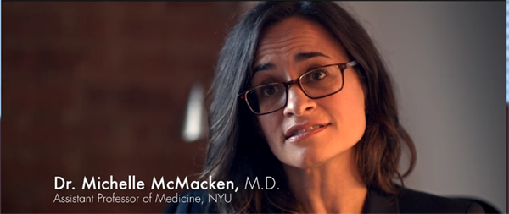
"Diet trumps cigarettes."

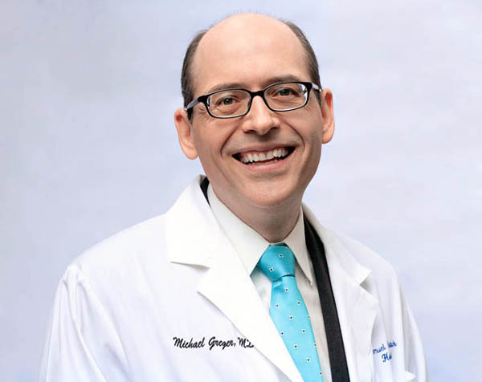
Is chicken better?
Dr Michael Greger, "It depends if you wanna be hung or shot."
More from Greger, (he has given more than 1000 lectures at Medical schools around the world)...

When we eat dead meat bacteria toxins [endotoxins] within minutes we get a burst of inflammation [toxemia] such that you paralyze your arteries. So it's not like decades down the road damage, no, we're talking about damage right then and there, within minutes of it going into our mouths."

So what is he talking about? See my posts on the last page for details, but here it is in pictures....first to know two things:
1. Our arteries are lined with endothelial cells that give off nitric oxide that keeps arteries and blood slippery, and also cause our arteries to expand under exertion. When the endothelial cells get fucked up a couple things happen, firstly with less nitric oxide, our arteries can't expand to let blood through so we get painful angina. Also, without nitric oxide so our arteries and blood get sticky..cholesterol sticks to the damaged areas and we get plaque buildup, high blood pressure, and die of heart attacks, (but the meat makers already got our money).
2. The bacteria in animal products (tens of millions of colonies in a hamburger), have two major effects, and being cooked dead doesn't matter:
a. The bacteria is made of toxic material that does damage to sensitive endothelial cells on contact, killing them, and...
b. The immune system reacts to the dead bacteria as though it were alive and releases toxic white blood cells (and other) in response. These white blood cells damage not only the bacteria, but good cells around the system, there is even strong evidence of chromosome damage and acceleration in aging as well as expanded disease span.
This doesn't happen with whole (unprocessed), plant foods.
Greger likens three meals a day for it's three, 5-hour bouts of toxemia (raised WBC), to banging your shin on the coffee table...if you bang it once it will get better, if you bang it three times a day every day it will never heal, and if you stop banging it, it will get better.
I'll blend pictures from two sources to try to get a visual...here's the deal...
Here's endothelial cells emitting nitric oxide, keeping things slippery, and regulating expansion and contraction of an "artery:"
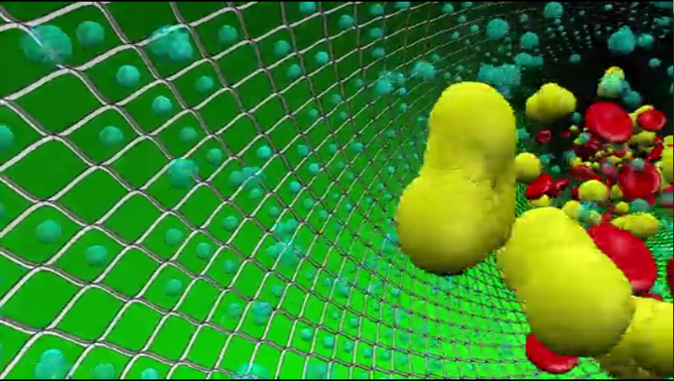
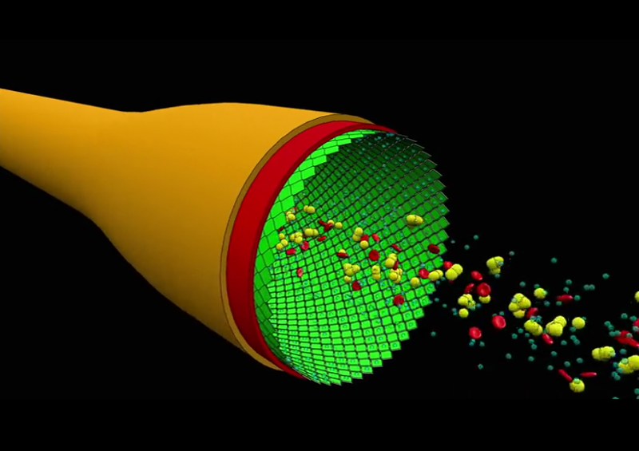
And along comes a happy meal, and it's saturated fat helps ferry its millions of dead bacteria colonies into your bloodstream. This bacteria is made of toxins which break down the structure of the endothelial cells on contact...
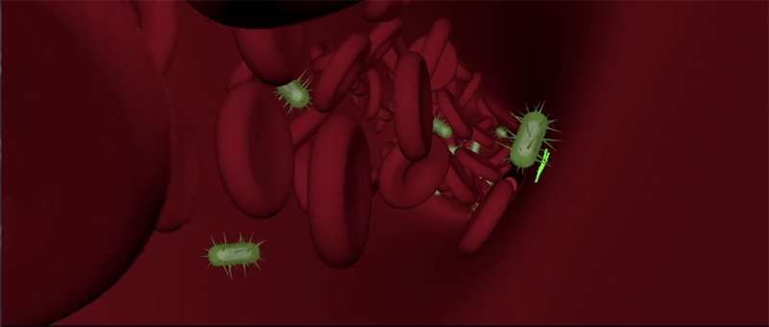
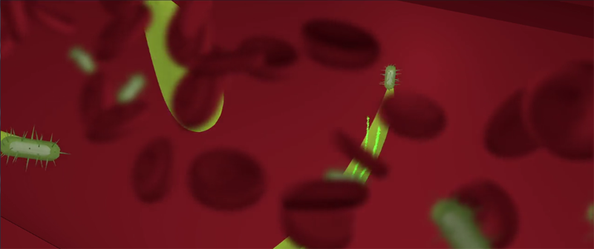
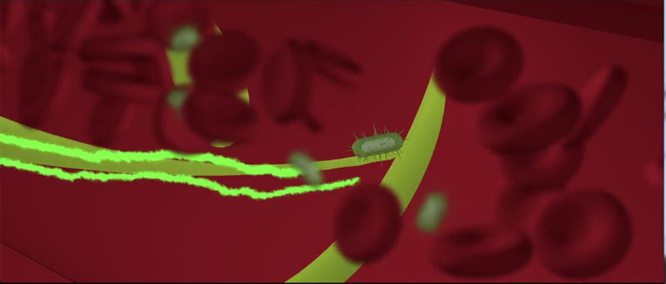
Not shown here is the dead bacteria ALSO triggers an immune response called toxemia, where the immune system releases white blood cells that attacks not only the bacteria, but healthy cells caught in the chemical crossfire... Direct damage to the cells, and genetic [rapid aging] damage to chromosomes.
Endothelial cells are damaged...
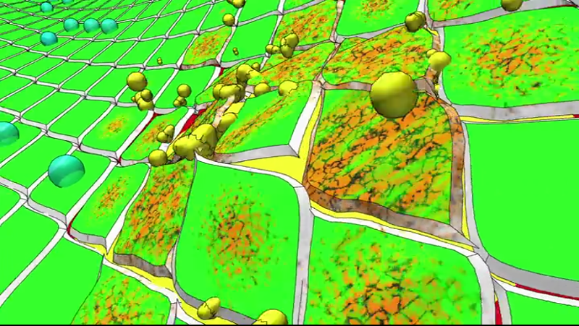
...more happy meals come...
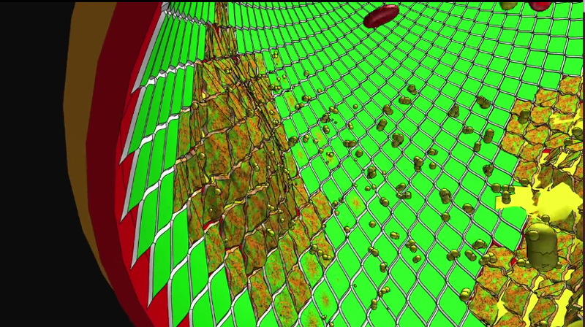
...and with less nitric oxide to make things slippery, cholesterol comes along and sticks to the damage, building up plaques and reducing blood flow, (nor can the arteries expand enough without enough nitric oxide to trigger it).
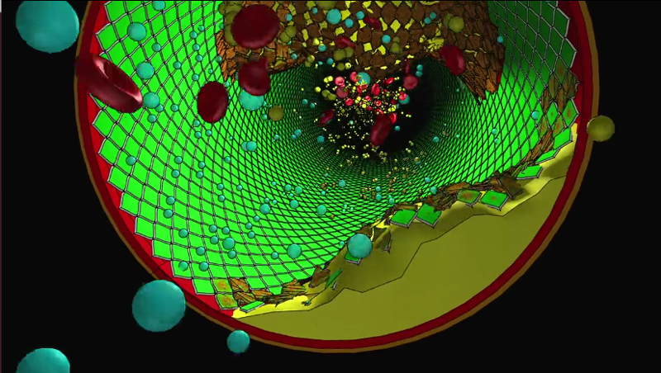
So that's basically the reason endotoxins in animal based foods are killing us. The good news is when one stops kicking their shin on the coffee table three times a day, it's normal for your shin to get better:
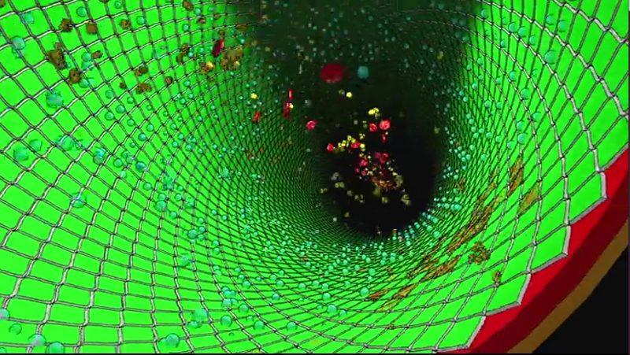
What is NOT talked much about in the above heart disease discussion is the connection of the toxic immune response to the bacteria in meats - to the chromosome damage that causes virtually all of the other "diseases of the aged." You don't get just one disease, you get them all, it's just which ones will be first, and will they kill you before you have time to get the other ones.
This effect is shortening the American life span from 100 to 86, and lengthening the disease span from a year or two, to 15 years of end of life suffering, is mostly caused by the Western diet, and is preventable

TURNING CANCER ON AND OF THEN ON AGAIN AND OFF AGAIN BY EARING DAIRY, THEN NOT EATING DAIRY:
GIVE YOURSELT CANCER, OR TURN OFF TCANCER, YOUR CHOICE.

Esselstyn took it one step further, he used ONE group of rats and turned their cancer on, then off, then on again, then off again, by simply switching their dairy protein calories.
This chart needs a little explanation: He gave them cancer with 20% dairy, then switched these SAME rats cancer off again by dropping them to 5%, their cancers turned off and reduced (way better than chemo and radiation and healthy, rather than deadly side effects).
At week 9 he gave them cancer again and they seemed more susceptible to increased cancer from dairy, then he switched them to 5% and turned off the cancers at 12 weeks that he had just given them at 9 weeks, (I wish he had kept them at 5% another 6 weeks to bring their cancers all the way down).
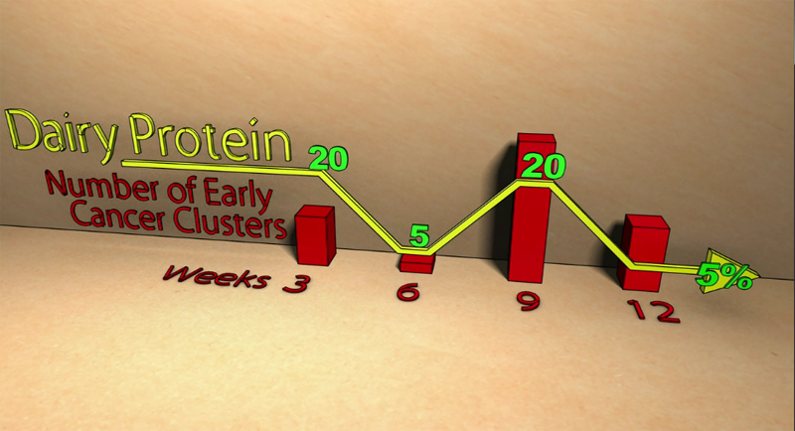
Something in animal based foods is very good at turning cancer on.

Breast cancer in the US as compared to the plant eaters of Kenya:


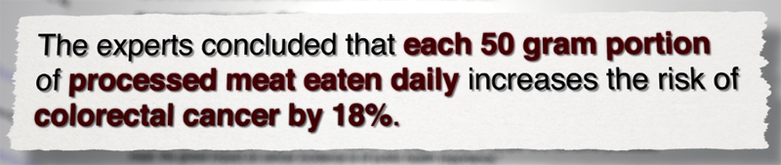

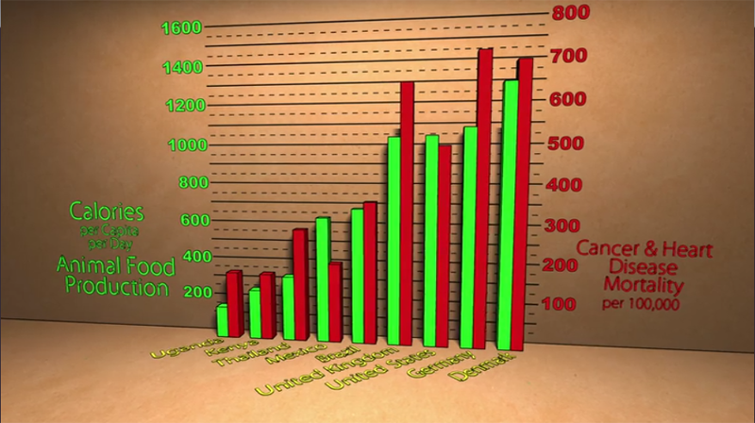

anyone want diabetes? Have a ham sandwich...
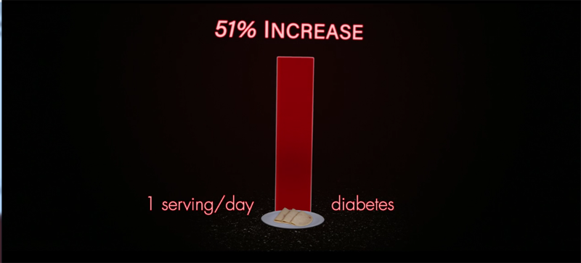

American's on a Western diet live to ~85, and have 15 years of increasing medical problems before they croak; the young guns here can change that to 100 year lifespan, with a disease span of only a year or few. Which line do you want to be on, it's completely your choice:
